

# Artemis Financial Vulnerability Assessment Report

Table of Contents

Document Revision History 3

Client 3

Instructions 3

Developer 4

1. Interpreting Client Needs 4

2. Areas of Security 4

3. Manual Review 4

4. Static Testing 4

5. Mitigation Plan 4

## Document Revision History

| **Version** | **Date** | **Author** | **Comments** |
| --- | --- | --- | --- |
| **1.0** | **09/17/2022** | **Brady Steele** | **Updated client needs, areas of security, manual review, static testing, and mitigation plan** |

## Client



## Instructions

Submit this completed vulnerability assessment report. Replace the bracketed text with the relevant information. In the report, identify your findings of security vulnerabilities and provide recommendations for the next steps to remedy the issues you have found.

* Respond to the five steps outlined below and include your findings.
* Respond using your own words. You may also choose to include images or supporting materials. If you include them, make certain to insert them in all the relevant locations in the document.
* Refer to the Project One Guidelines and Rubric for more detailed instructions about each section of the template.

## Developer

Brady Steele

## Interpreting Client Needs

Artemis Financial is, in rather obvious terms, a financial institution. This means that Artemis Financial handles financial data for customers. This type of data is very sensitive and valuable in nature, which makes it very desirable for a bad actor to gain access to. This company needs to place a high value of the security of their communications and data transfer, to protect this information. Governmental standards must also be employed for the handling of this data, and the application must comply with federal laws and best practices. The API needs to be secure, with proper authorization in place to ensure that the information is being used in a secure way. The API must be conducted through HTTPS, to maintain secure, encrypted connections between the requester and responder.

## Areas of Security

The areas of security that are applicable to the Artemis Financial application are code quality, code errors, cryptography, input validation, and APIs. Code quality is important for this application, because poorly written code can lead to unexpected vulnerabilities and insecure data. This leads into the next area, which is code errors. Poor quality code will typically include errors. Errors in the code can leave data unprotected and allow for unintended access or actions on the system. Cryptography is necessary, through HTTPS transport layer security for the API. Encrypting the information that is being requested and sent back to the web page is very important, to protect the requested data from outside access. Input validation is important, because the users will have to use proper inputs to send and receive information to and from the API, and we need to make sure that the proper information is being passed. Lastly, APIs and secure API interactions are very necessary, as the API is the main process of this web page. Secure the interactions between the user and the API ensures that the data being sent cannot be breached.

## Manual Review

* In the CRUDController.java, business names are passed as a public object in the request parameter, leaving this information vulnerable.
* In the DocData.java, the database login credentials are hardcoded in the read_document class, and not abstracted. This means that root access to be given to an unauthorized party.
* I do not see any authentication or user validation outside of database access.
* I do not see any input validation for user requests.
* I do not see any indication that HTTPS transport layer security is in place for the API connections.

## Static Testing

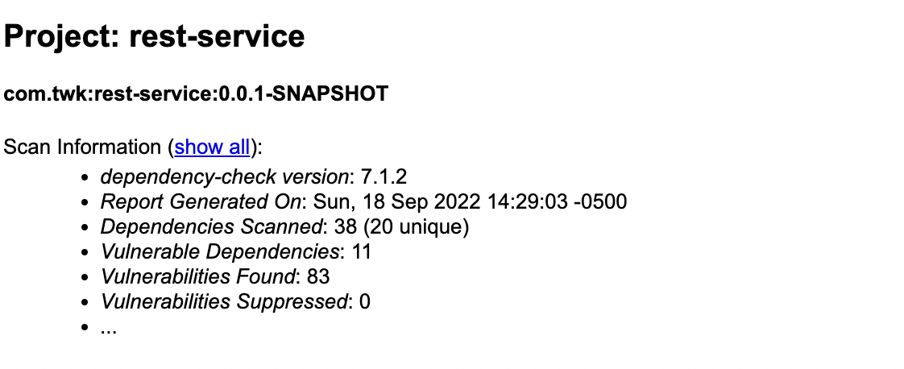

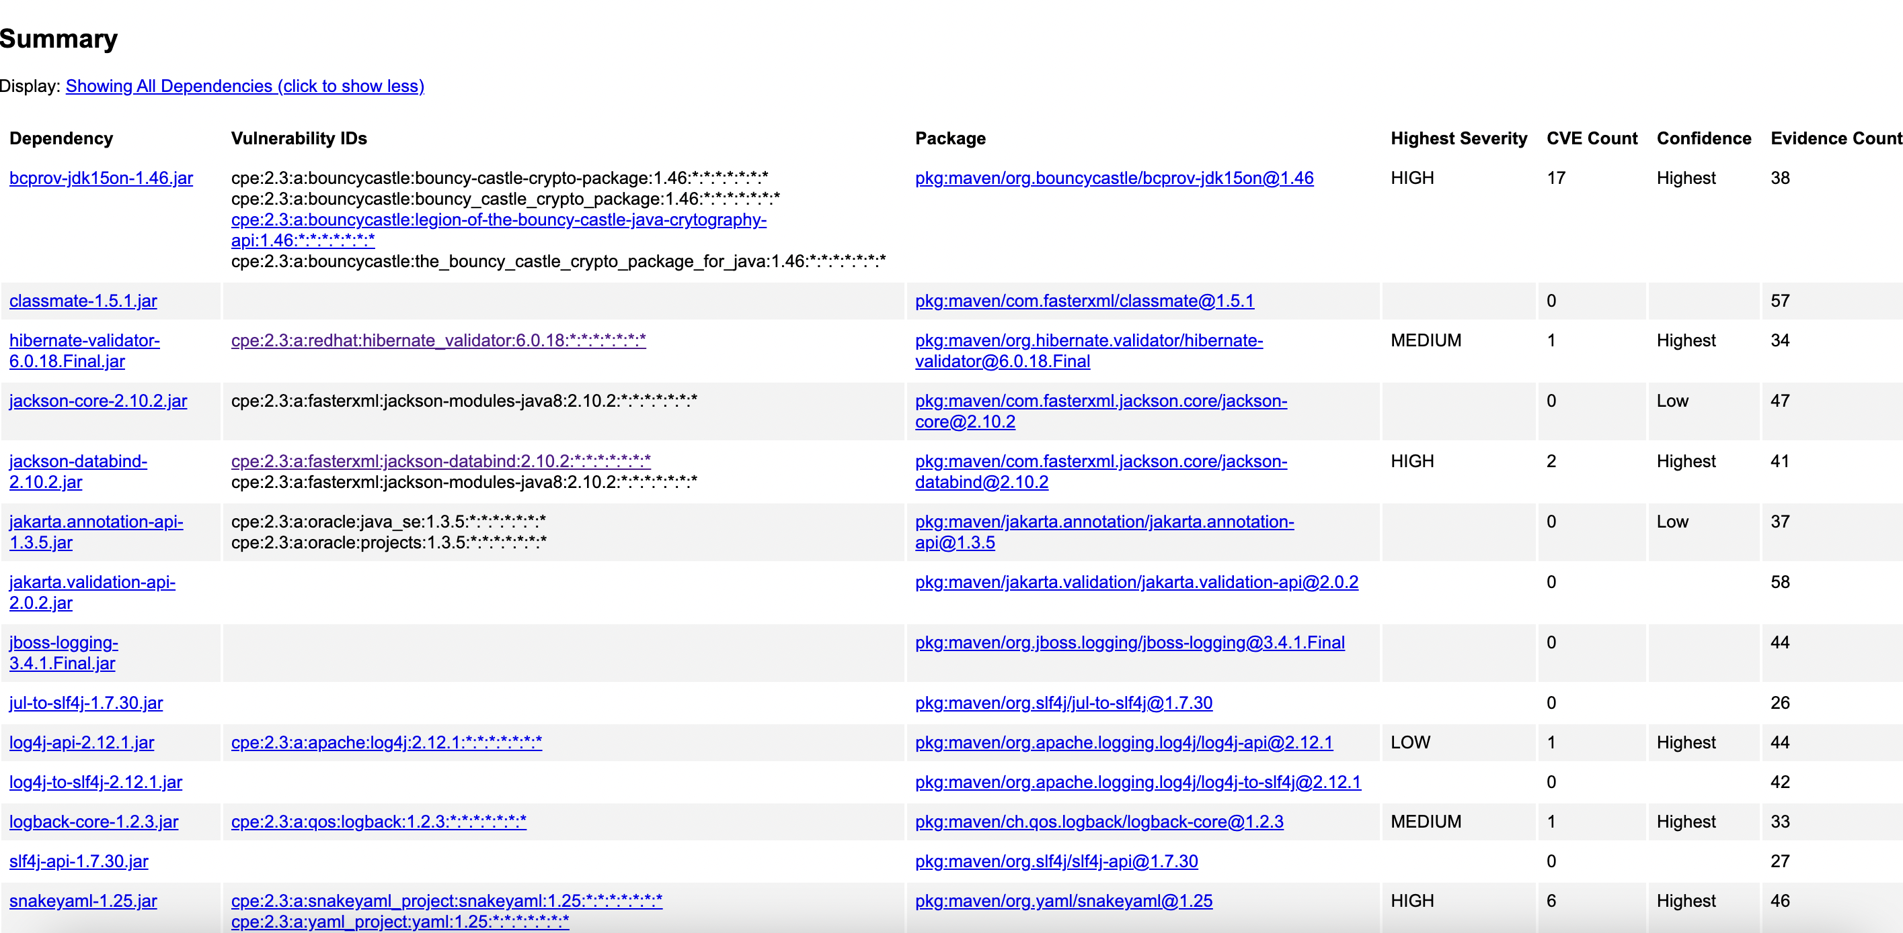

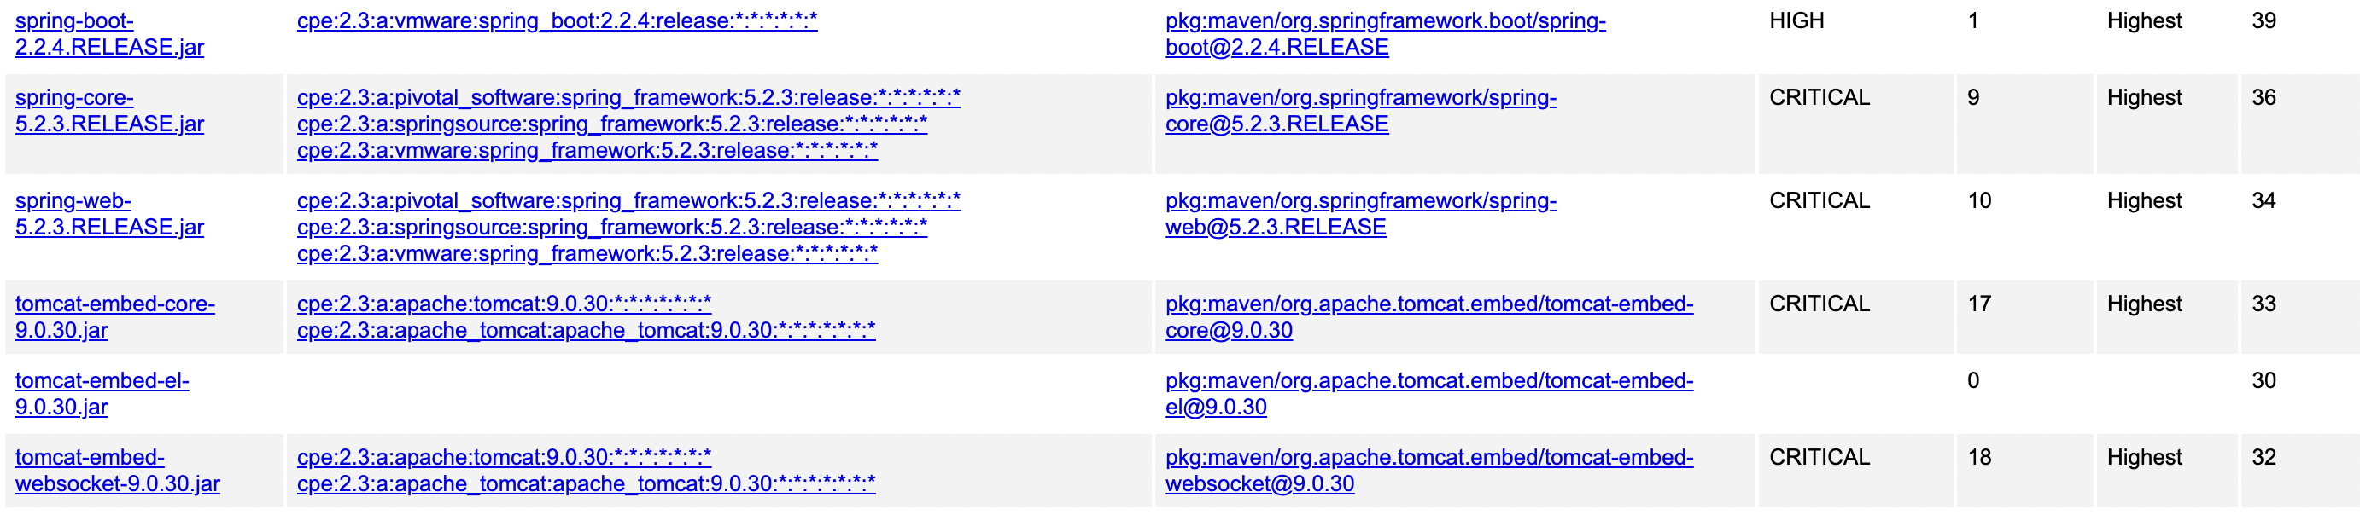

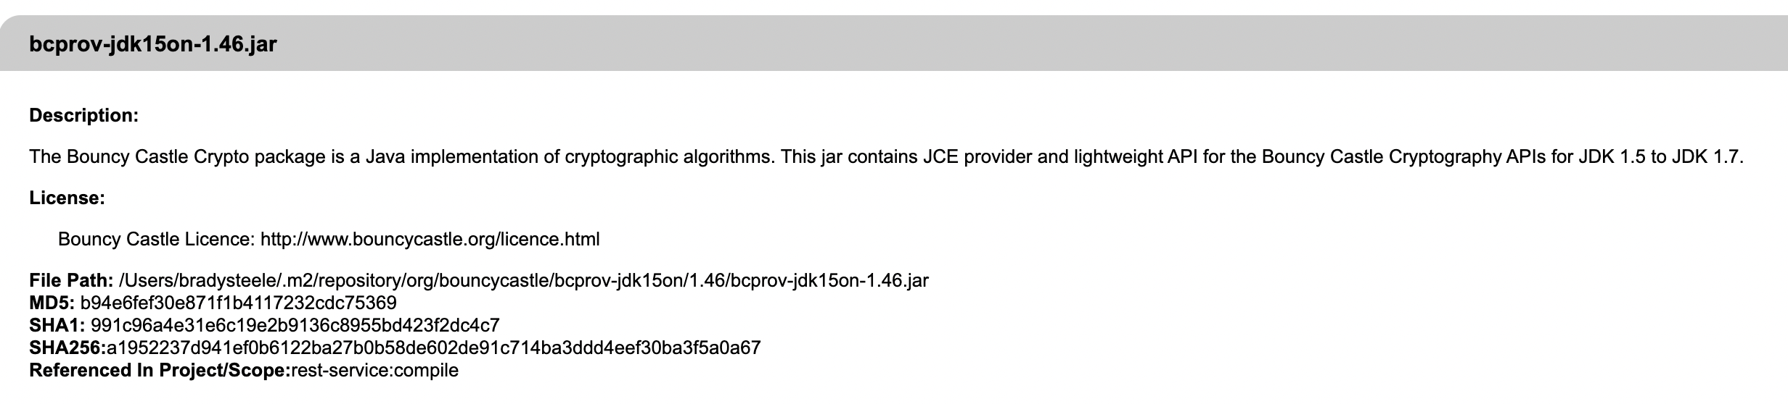

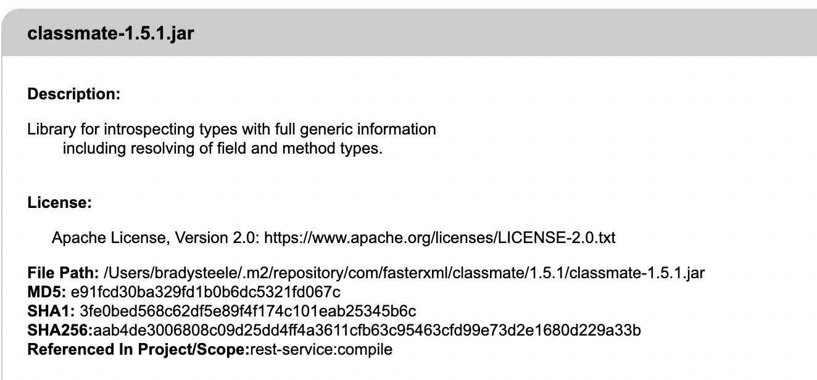

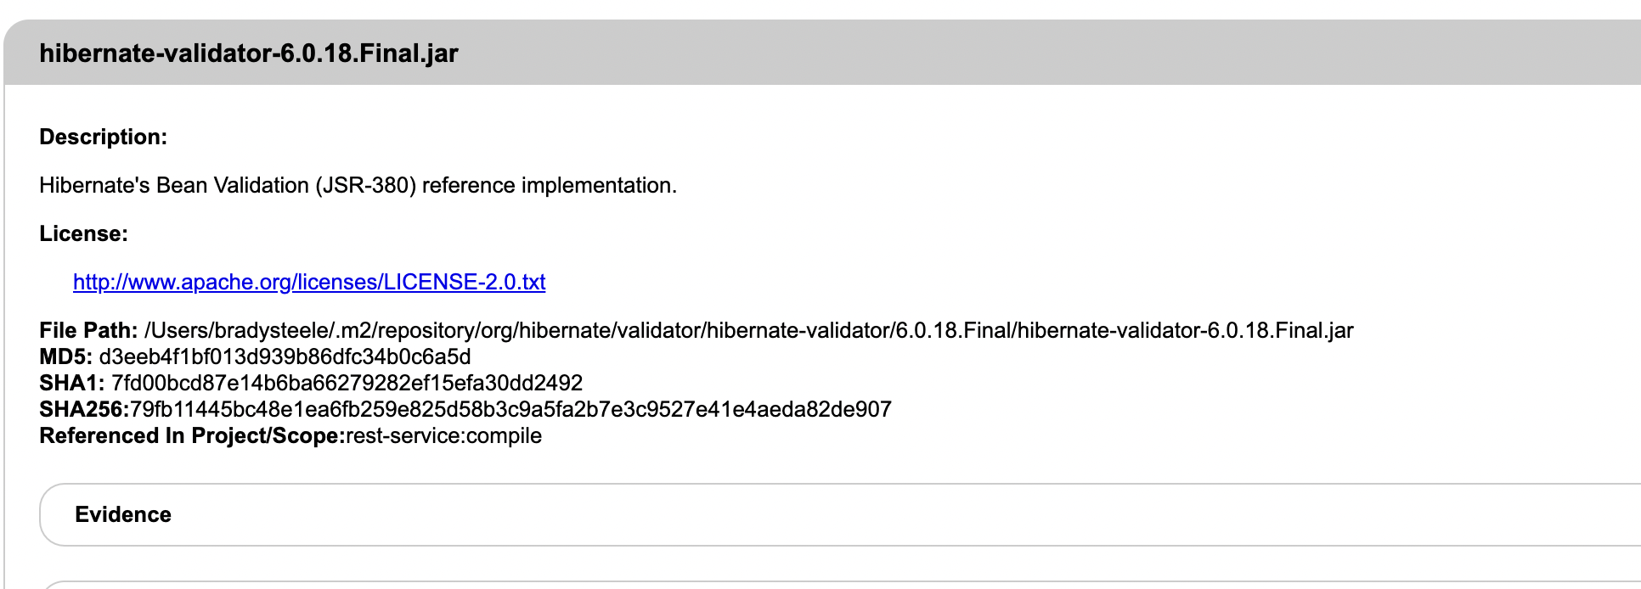

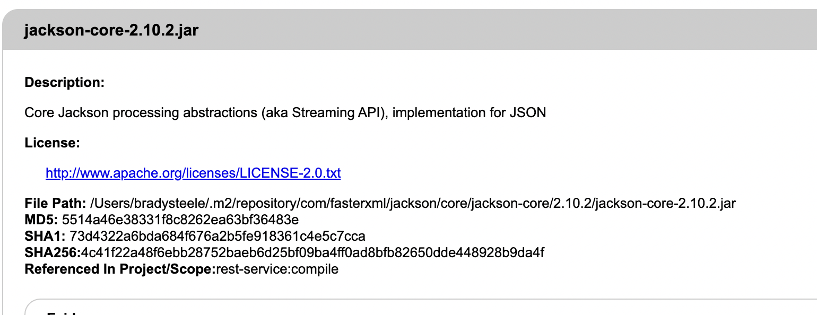

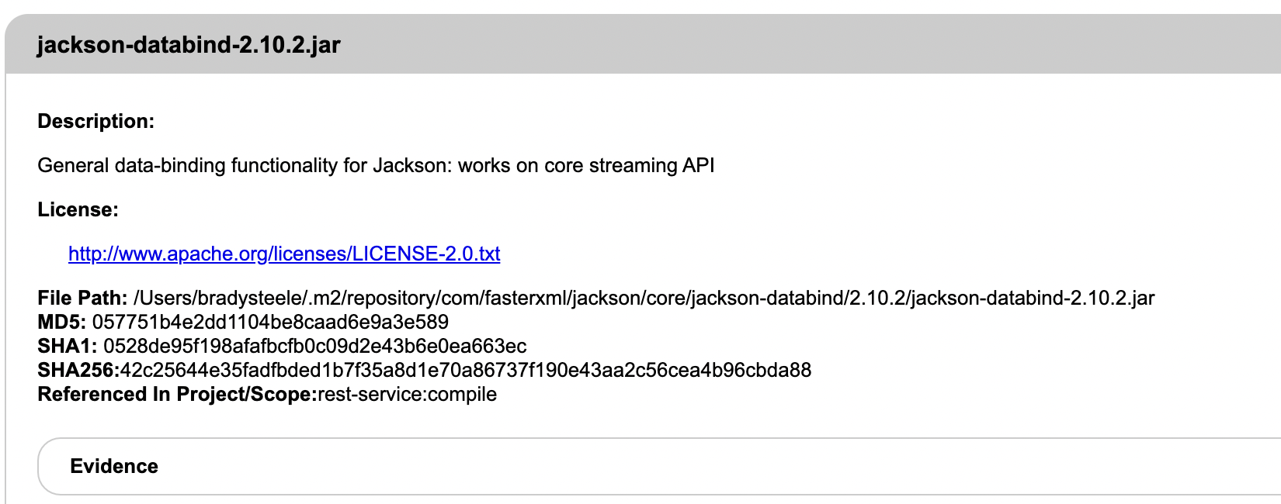

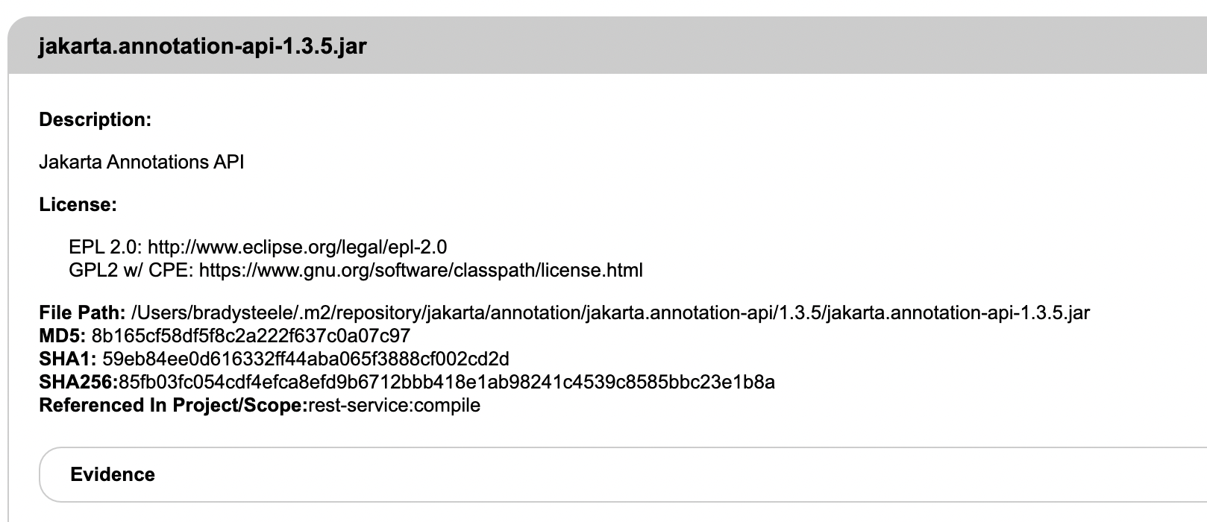

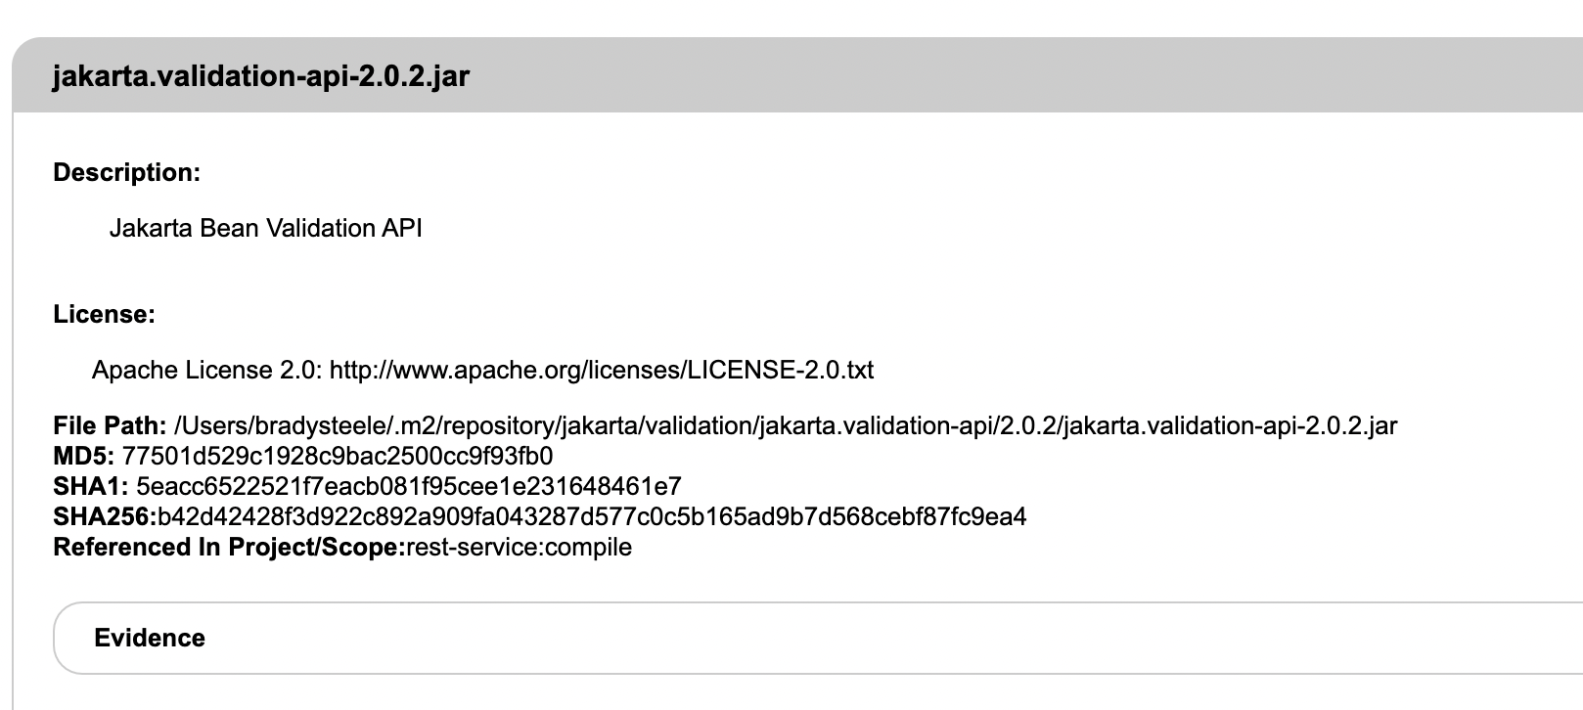

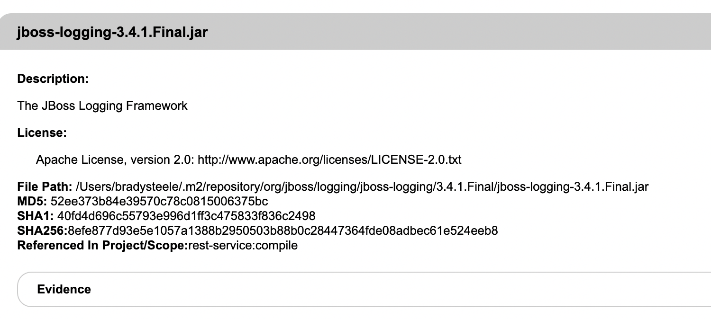

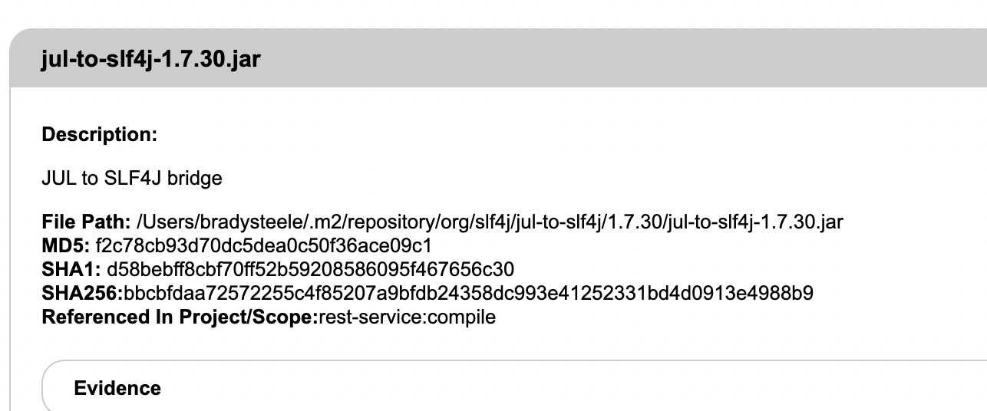

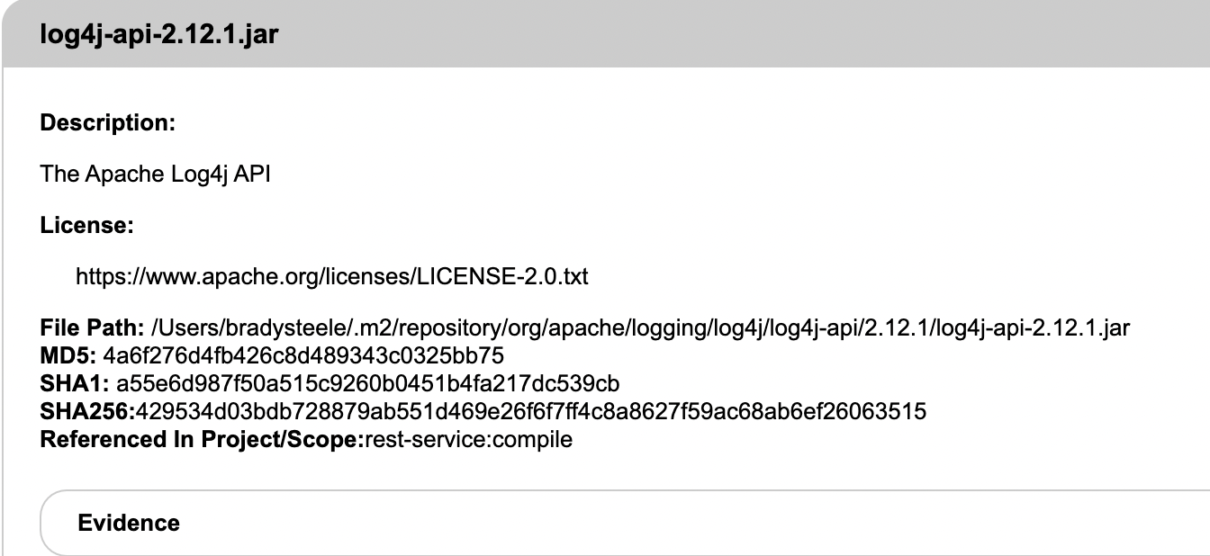

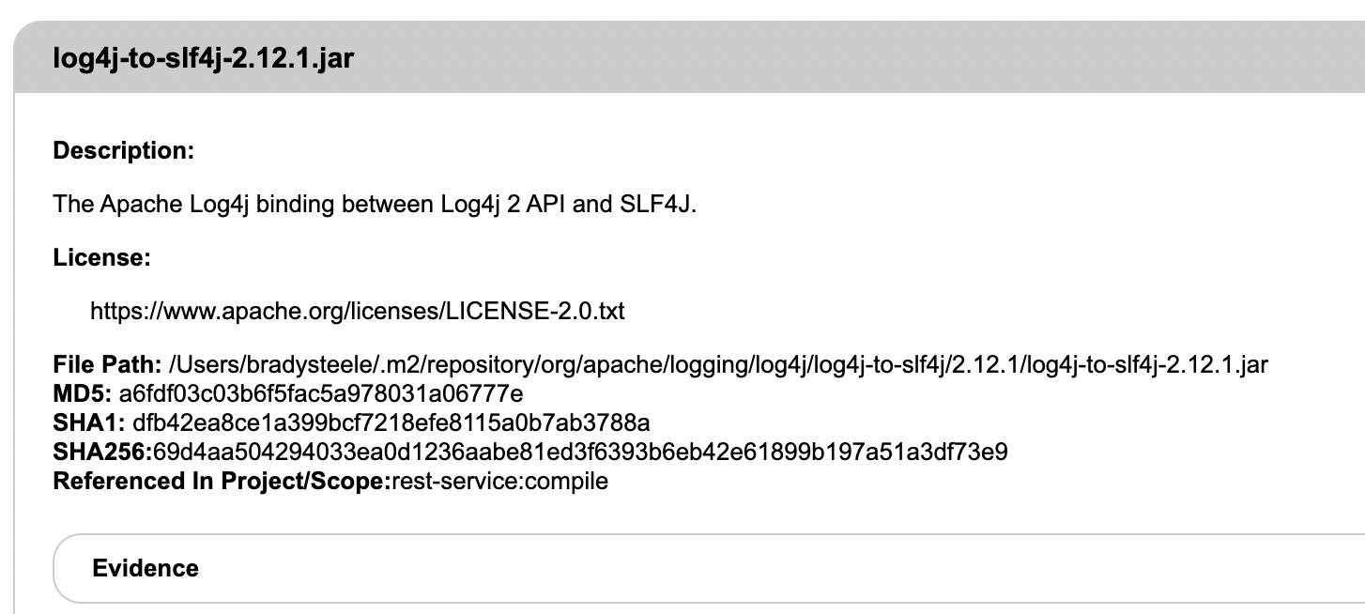

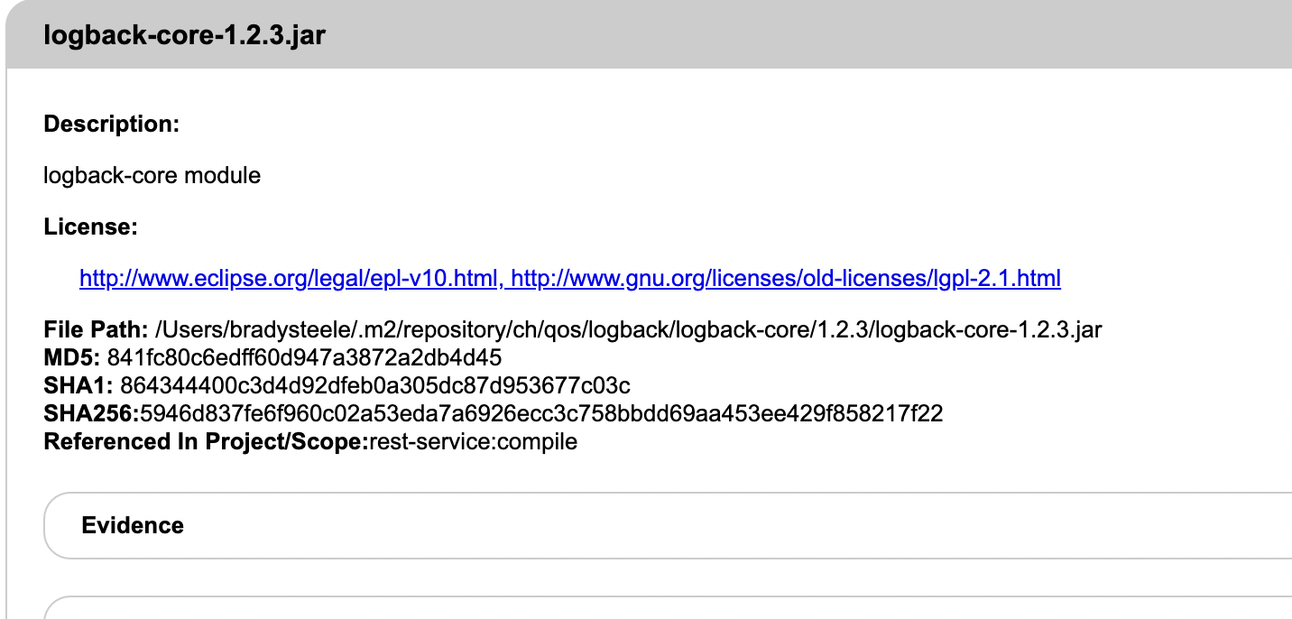

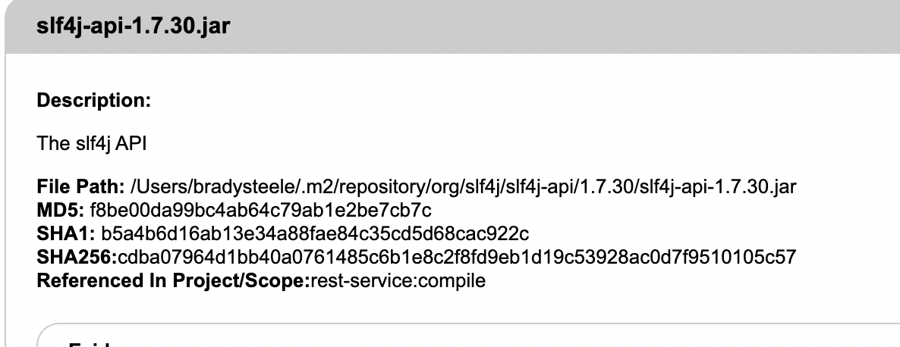

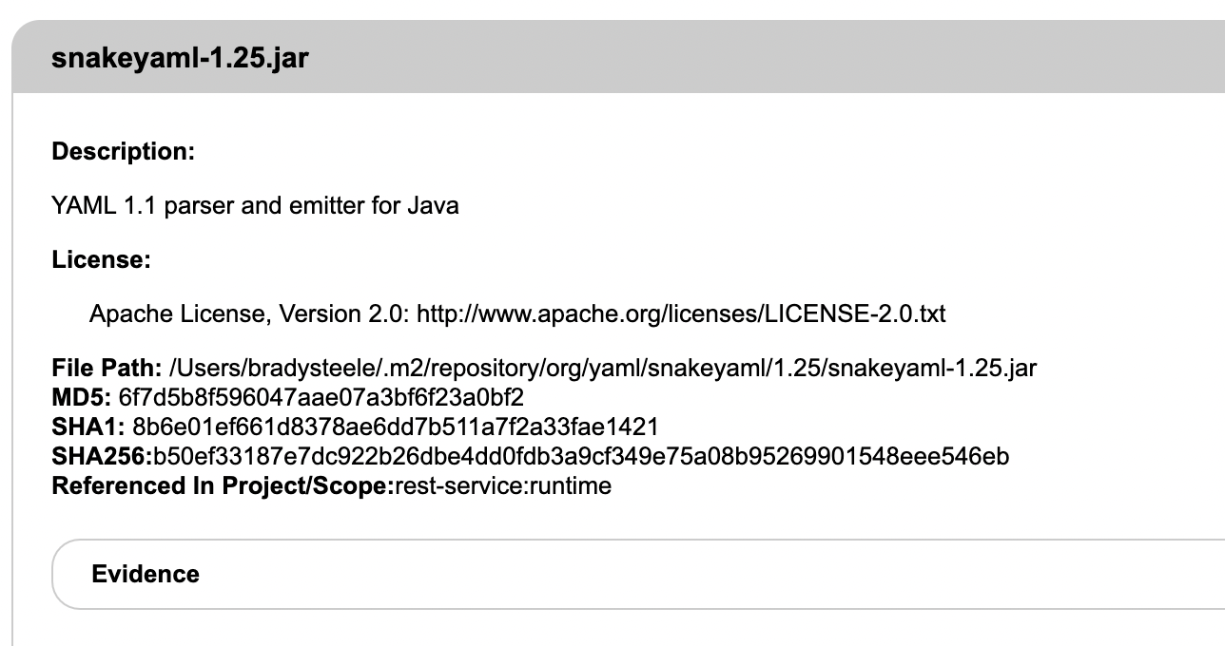

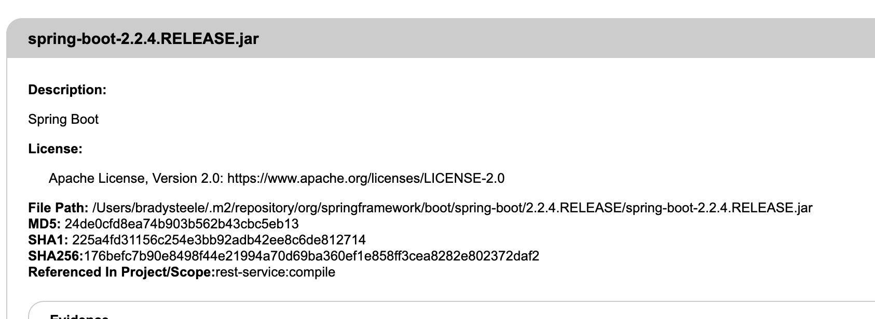

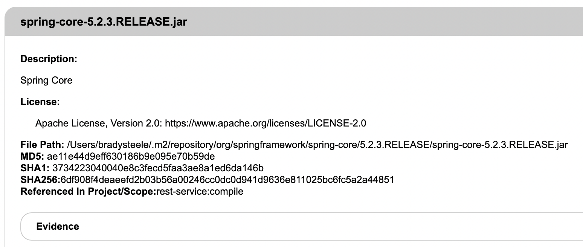

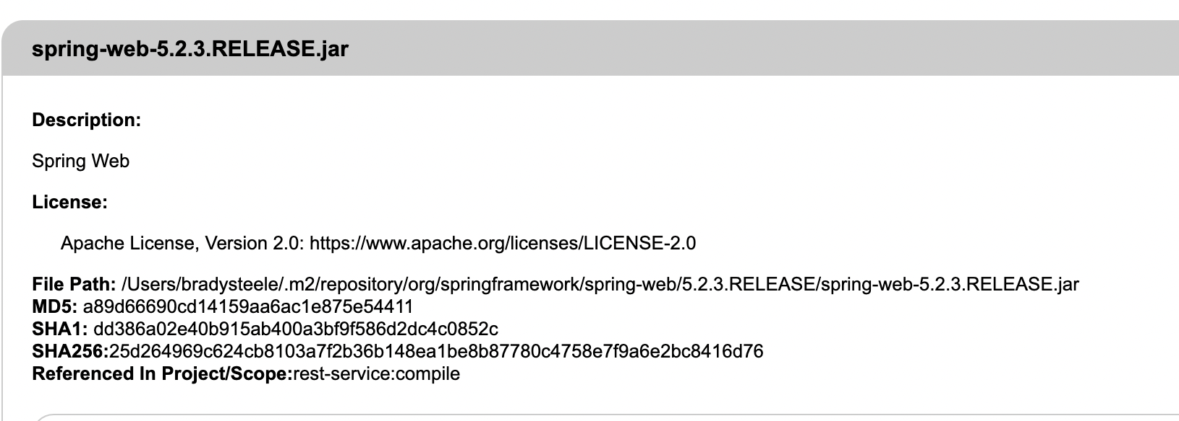

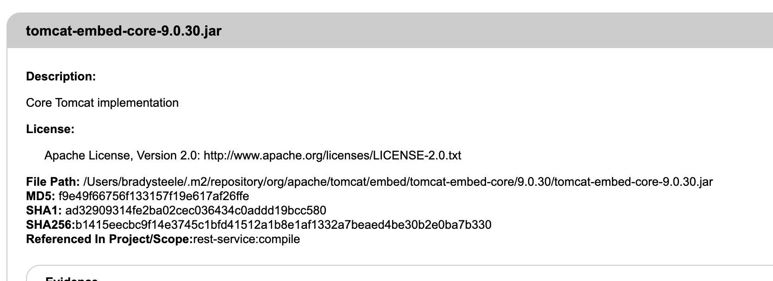

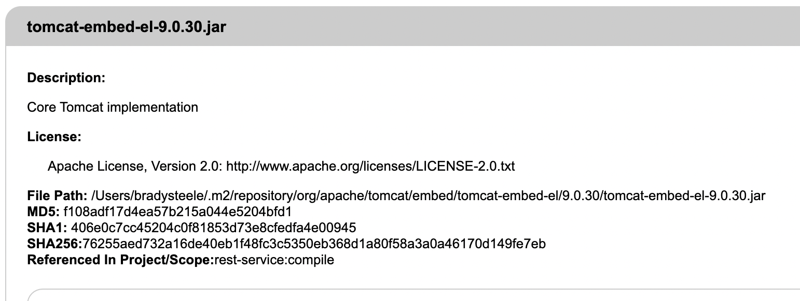

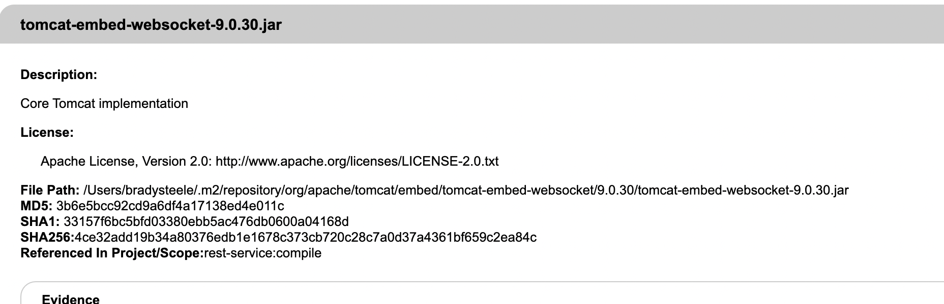

## Mitigation Plan

To remedy these vulnerabilities, we will need to incorporate some changes to the code base. First, we need to get rid of the hard coded credentials and data, so that it can be abstracted away from anyone that might misuse the information. The information can be structured as request headers within the API. Input validation needs to be implemented, so that users can not just pass whatever string information they wish to the API. Next, authorization needs to be implemented to access the API, so that only users with the correct access, can send requests and receive responses. Lastly, the dependencies from the above report need to be remedied.